# Cyber Security and Ethical Hacking

## VMware Workstation 17 Player

Link: <https://softwareupdate.vmware.com/cds/vmw-desktop/player/17.6.0/24238078/>

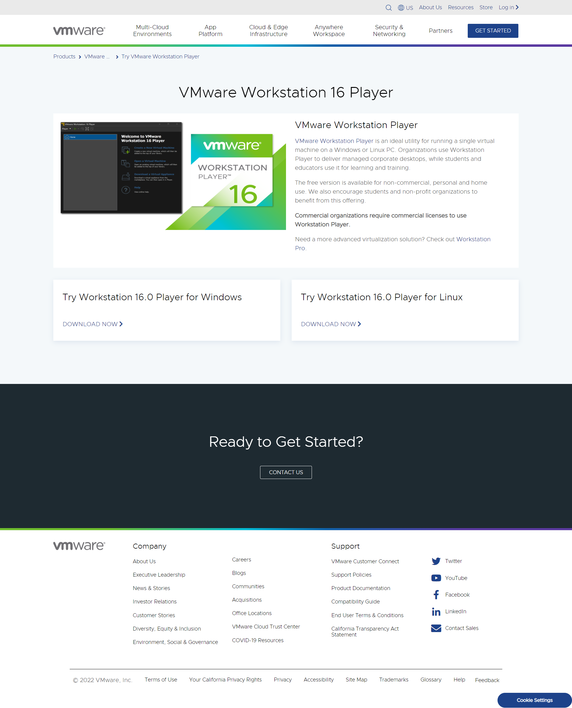

## Kali **Linux** VMware & VirtualBox

Link: <https://www.kali.org/get-kali/#kali-virtual-machines>

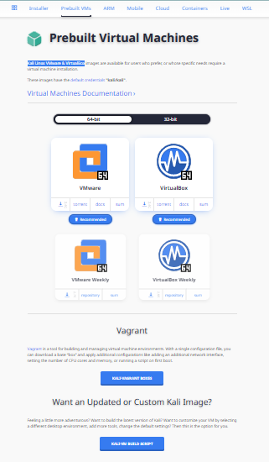

## Get Ubuntu Server

Link: <https://ubuntu.com/download/server>

